**How to download and install java software**

1. **Open the google search engine**

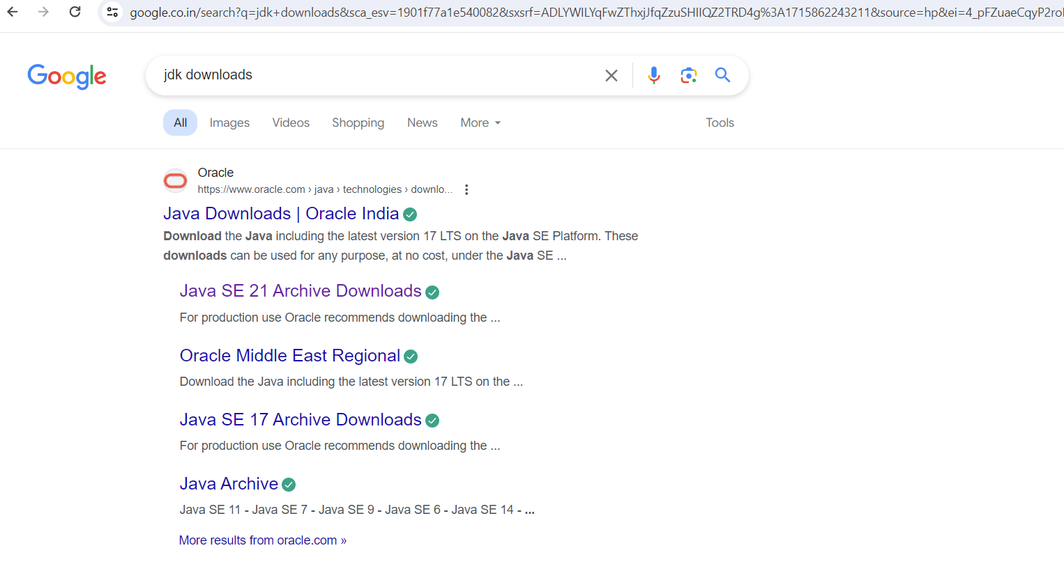

1. **Click on the first link**

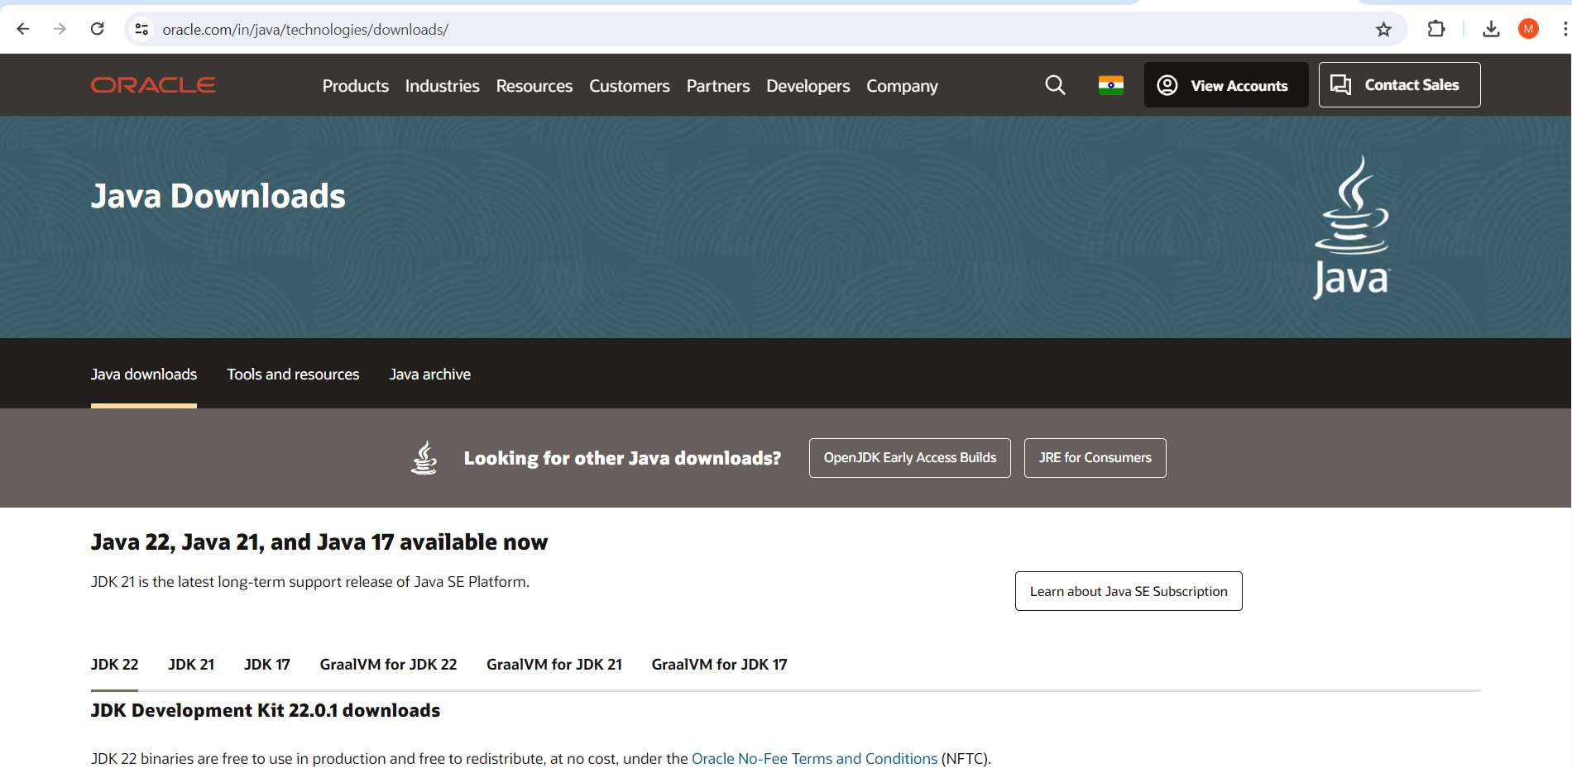

1. Choose the version and operating system and download it. Or directly use the below link to down load java22 version

<https://download.oracle.com/java/22/latest/jdk-22_windows-x64_bin.exe>

1. After download double click on the download .exe file to start installation
2. allow app to install
3. next
4. next
5. close
6. installation done

**Setting path and java home**

**Path setting**

1. **copy the “C:\Program Files\Java\jdk-22\bin” path**
2. **click window button and search for Edit The system environment and click on it**

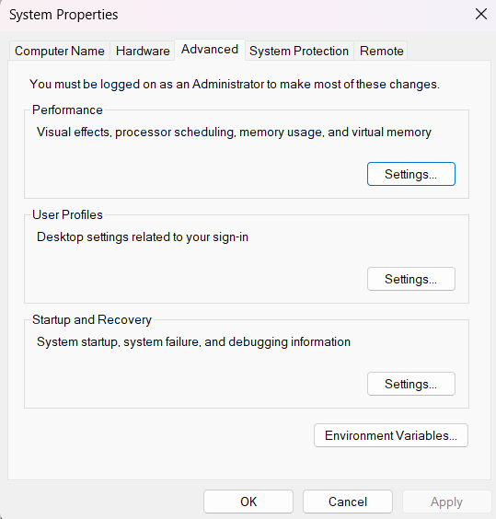

1. **click on Environment Variables button**

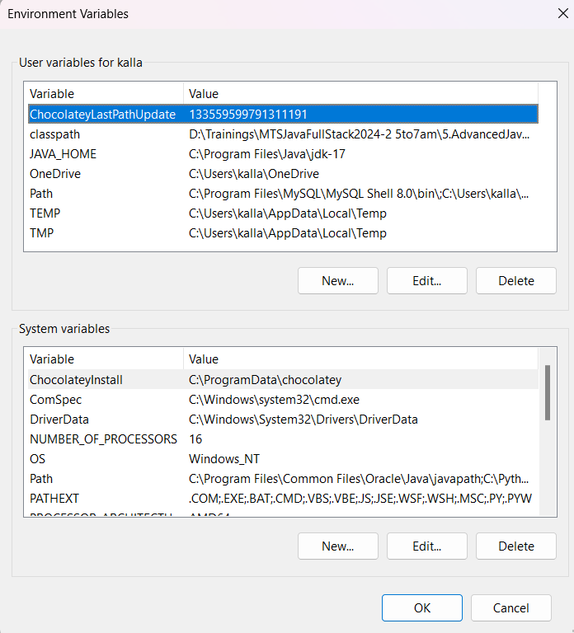

1. **select the variable path and click on edit and click on new and past the copied path**

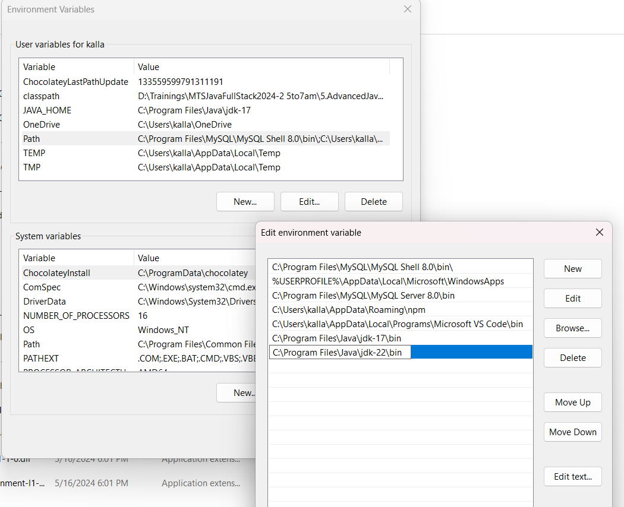

1. **click on okàokàok**
2. **path setting is done**

**Java home setting**

1. **click on new button from the below window**



1. **set variable name and value like below and click on ok,ok,ok**

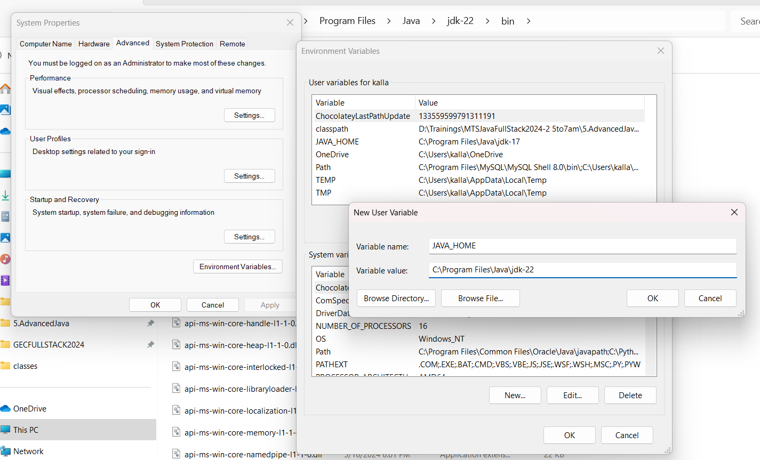

1. **Java home setting is done**

**99122 80626**